

**Customer Churn Prediction in Ecommerce Business using Deep Learning Models**

**By: STEPHEN MULINGWA**

**2024**

**Customer Churn Prediction in Ecommerce Business using Deep Learning Models**

**Chapter 1: Introduction**

* 1. **Background**

Top of FormLoyal customers are essential in improving business performance and can boost an enterprise's core competitiveness. In addition, loyal customers can help enterprises reduce the cost of publicity and negotiation and attract more new customers, thus lowering customer development costs and increasing the opportunities and time for enterprises to obtain basic profits (Zhao et al., 2021). They can also increase the chance and time for businesses to earn basic profits, assist enterprises in earning premium income, consolidate the market position, reduce market risks, and raise entry barriers for other companies.

Customer churn is a critical issue frequently linked to the business's current cycle. When a company is in the development stage of its life cycle, deals grow exponentially, and the number of new clients far outnumbers the number of churners (Kriti, 2019). On the other hand, organizations in a mature life cycle place a premium on reducing customer churn. The primary causes of customer churn are classified as either accidental or intentional. Accidental churn occurs when conditions change, preventing customers from using services in the future, such as financial conditions that make benefits unreasonably expensive for the client. Intentional churn occurs when customers switch to another organization that provides comparable services, such as better ideas from competitors, more developed services, and a lower cost for a similar product or service.

In the rapidly evolving landscape of e-commerce, where competition is fierce and customer choices are abundant, the significance of churn prediction cannot be overstated. E-commerce platforms thrive on customer engagement, making retention strategies as critical as customer acquisition. Predicting churn enables companies to pre-emptively address factors contributing to customer attrition, thereby fortifying relationships and fostering loyalty. Moreover, in the digital realm, customers have a myriad of alternatives at their fingertips, making prompt identification of potential churners pivotal for personalized interventions and tailored experiences. E-commerce entities leveraging predictive models gain a competitive edge by proactively preserving customer relationships and curbing revenue leakage.

The evolution of churn prediction techniques has undergone a transformative journey, particularly in the field of deep learning. Traditional methods predominantly relied on statistical models, whereas the advent of deep learning has revolutionized predictive analytics. Neural networks, recurrent neural networks (RNNs), and convolutional neural networks (CNNs) have exhibited remarkable prowess in handling complex data sets and discerning intricate patterns within e-commerce consumer behaviour. The amalgamation of these sophisticated techniques with vast data repositories empowers e-commerce entities to delve deeper into customer behaviour nuances, offering a nuanced understanding of churn dynamics and enhancing the precision of predictive models.

Many businesses concentrate on acquiring new customers while ignoring the need to retain existing customers and increase their consumption potential, e-commerce being no exception. Reichheld and Sasser (2014) discovered that the longer a company's business relationship with its customers lasts the more profits it will make from its existing customers. The net present value of customers in the business environment increases by 25% to 95% for every 5% increase in customer retention rate (Reichheld & Sasser, 2014). According to Jones and Sasser (2014) research, when an enterprise's customer churn rate falls by 5%, the enterprise's average profit rate rises by 25%-85%. As a result, the practical significance of customer churn prediction is that it will benefit businesses financially.

While the pursuit of enhancing customer retention through churn prediction is paramount, ethical considerations and safeguarding customer privacy remain pivotal. The collection and analysis of consumer data to predict churn must be conducted with stringent adherence to data privacy regulations and ethical guidelines. Maintaining transparency regarding data usage, seeking explicit consent for data collection, and deploying robust security measures are imperative. E-commerce enterprises must strike a delicate balance between leveraging predictive analytics for enhancing customer experiences and respecting customer privacy, fostering trust and credibility in an era where data ethics are under constant scrutiny.

For starters, loyal customers have a higher retention rate than new customers, and the likelihood of competitive marketing activities is lower. Additionally, because the enterprise knows the preferences of existing customers, the cost of providing services is lower. Secondly, churned customers may refer other customers in their social network to competitors, whereas loyal customers will bring in more new customers. Thirdly, customer churn results in missed cross-selling and up-selling opportunities, resulting in a decrease in profits. Predicting customer churn behaviour, analysing the root causes of customer churn, identifying the links that need to be improved in the operation and management process, regaining churned customers, and establishing a stronger customer relationship have all become strategic priorities for businesses in the e-commerce industry.

While defection rates are a good predictor of profit swings, they do more than show where profits are going. They also direct managers' attention to the reasons customers are leaving. Companies cannot keep customers captive, so the only way to keep them is to outperform the competition consistently. Companies that solicit feedback from defecting customers can identify and strengthen the weaknesses that matter before profits begin to dwindle. Defection analysis is thus a guide that assists businesses in managing continuous improvement.

Implementing predictive analytics for customer churn prediction in e-commerce is not without its challenges. Handling vast amounts of data while ensuring its accuracy and relevance poses a significant hurdle. Moreover, the ethical considerations surrounding data privacy, consent, and the responsible use of consumer information are paramount. E-commerce companies must navigate the fine line between leveraging consumer data to enhance service offerings and respecting individual privacy rights. Striking a balance between data-driven insights and ethical considerations is essential to foster trust and credibility among customers while reaping the benefits of predictive analytics.

While predictive analytics offer unparalleled insights, it's crucial not to overlook the human element in customer relationship management. Over-reliance on data-driven models might overshadow the nuanced human interactions that drive customer loyalty. Companies should complement predictive models with empathetic customer service, personalized human touchpoints, and genuine engagement. Balancing the efficiency of predictive analytics with the empathy and intuition of human-centric approaches is pivotal in crafting a holistic customer retention strategy.

In the dynamic realm of e-commerce, embracing a culture of continuous learning and adaptation is fundamental. Predictive models, though robust, require constant calibration and refinement to align with shifting consumer behaviors and market dynamics. Companies must adopt a mindset of agility, fostering an environment where feedback loops and data-driven insights are used iteratively to refine predictive models. This iterative process not only improves the accuracy of churn predictions but also enables businesses to stay attuned to evolving customer needs, ensuring sustained relevance and competitive advantage in the ever-evolving e-commerce landscape.Top of Form

In today's dynamic market dynamics, businesses need to pivot swiftly and embrace a culture of continuous improvement. Stagnation is no longer an option. Monitoring market shifts, competitor strategies, and technological advancements becomes essential. Companies that embrace agility and adaptability, iterating on their offerings, services, and operational efficiency, are better positioned to cater to evolving consumer demands. Through a holistic approach that combines predictive analytics, personalized strategies, proactive customer engagement, and continuous improvement, e-commerce enterprises can not only predict customer churn but also effectively navigate the ever-changing landscape while fostering sustained growth and profitability.

This study presents a novel way of predicting customer churn using deep learning techniques for e-commerce businesses. This will allow e-commerce companies to identify the section of customers likely to switch to competitors. Along with the model, the study developed a consumer-facing tool for businesses to utilize for profit maximization giving them access to tools for customer retention. Reducing defections in half will more than double the average company's growth rate.

This study delves into the realm of customer churn prediction in e-commerce, employing cutting-edge deep learning methodologies. It aims to provide a comprehensive understanding of the factors driving churn and offers insights into predictive models to identify potential churners. The subsequent chapters of this study will delve into the methodology employed, the data collection and preprocessing techniques, the development and evaluation of the predictive model, and conclude with recommendations for e-commerce enterprises to leverage churn prediction for sustainable growth and enhanced customer relationships.

* 1. **Statement of the Problem**

**What:** The primary challenge within Kenya's e-commerce industry revolves around the concerning rate of customer churn, marked notably by a low retention rate of 4.6%. This alarming trend illuminates the critical need for effective measures to counteract customer attrition, especially amidst the rapid advancement of technology and the intensifying competition among market players.

**Why:** Existing circumstances underscore a crucial gap in conventional approaches. Traditional accounting systems lack the capacity to comprehensively gauge the lasting financial repercussions of customer departure, concentrating instead on immediate financial metrics. However, industry-wide evidence highlights the correlation between prolonged customer retention and amplified profitability over time. Accurate prediction of customer churn emerges as an imperative for business viability, given the direct relationship between sustained customer relationships and long-term financial gains.

**How:** Addressing this challenge requires a transformative solution. The Project centers on the development and implementation of a sophisticated customer churn prediction tool. This tool harnesses the capabilities of advanced machine learning techniques to forecast and proactively anticipate churn. By leveraging insights gleaned from customer behavior analysis and identification of pertinent churn indicators, businesses can craft tailored retention strategies, thus mitigating churn risks and fortifying customer loyalty in this competitive e-commerce landscape.

* 1. **Objectives**
     1. **Main Objective**

To predict the customer churn rate in e-commerce using deep learning techniques in machine learning.

* + 1. **Specific Objective**

1. To implement and optimize a Recurrent Neural Network (RNN) model for predicting customer churn in e-commerce, ensuring specificity in the choice of architecture and hyperparameters.
2. To implement and optimize a Convolutional Neural Network (CNN) model for predicting customer churn in e-commerce, specifying the architecture and hyperparameters for effective performance.
3. To conduct a comprehensive comparison between the RNN and CNN models, utilizing relevant metrics such as accuracy, precision, recall, F1 score, and ROC-AUC, to inform a data-driven decision on the most suitable model for predicting customer churn in the e-commerce context.

**1.4 Significance of the Study**

Customer prediction models play a crucial role in solving customer retention issues and helping businesses build stronger relationships with their users. In various industries, businesses have recognized the importance of reducing customer churn and have taken proactive measures to retain their existing customer base. By understanding the hierarchical dynamics of user behavior and identifying the underlying causes of churn, companies can implement targeted strategies to maximize customer retention. Rather than solely focusing on acquiring new customers, firms have started prioritizing the potential of their existing customer base. This shift in mindset allows businesses to capitalize on the untapped potential of their current customers.

To achieve the best customer retention outcomes, it is essential to transform the customer's status from being unknown to known. This involves predicting the customer's future decisions, which can be a highly complex task. However, by leveraging churn prediction models, businesses gain valuable insights into early warning signs and patterns that indicate a customer's likelihood of churning. By accurately forecasting customer churn, e-commerce players and other businesses can take proactive measures to prevent churn from occurring in the first place. This empowers companies to implement targeted strategies, personalized offers, and tailored interventions to retain customers before they decide to leave.

The implementation of customer prediction models not only helps lower customer churn rates but also extends the average duration of customer relationships. As customers stay loyal and engaged for longer periods, businesses can reap the benefits of increased customer lifetime value and profitability. Customer prediction models offer businesses the opportunity to foresee and anticipate customer churn, enabling them to implement effective strategies for retention. By leveraging these models, companies can reduce churn rates, extend customer relationships, and ultimately boost their overall profitability.

**Chapter 2: Literature Review**

**2.1 Introduction**

The e-commerce industry grapples with a pressing challenge: customer churn. Identifying and predicting potential churners before they disengage has become paramount, necessitating the creation of a robust classifier for proactive intervention. This literature review delves into deep learning models that can be used to explore the landscape of customer churn prediction in e-commerce, aiming to dissect prevalent factors, algorithmic methodologies, and gaps within the existing research while laying the groundwork for a proposed conceptual model where the existing literature falls short, a conceptual model of the proposed system is used.

**2.2 Models**

**2.2.1 Recurrent Neural Networks (RNN)**

Customer churn prediction has emerged as a critical pursuit within e-commerce, prompting extensive research into the efficacy of Deep Learning Models, particularly Recurrent Neural Networks (RNNs), in this domain. Zhang, et al. (2018) conducted a study comparing LSTM networks, a type of RNN, against traditional machine learning models for customer churn prediction in e-commerce. Their comprehensive analysis illuminated the superior ability of LSTM networks to capture intricate sequential patterns inherent in e-commerce data, offering a more nuanced understanding of customer behavior shifts, thereby facilitating early identification of potential churners. This study underscores the pivotal role of RNN-based models, particularly LSTM, in enabling e-commerce businesses to proactively address customer attrition.

In a bid to augment churn prediction accuracy, a study on the nature of communications delved into attention-based RNN models for customer churn prediction in e-commerce platforms (Wang, 2020). By integrating attention mechanisms into RNN architectures, their research aimed to elevate churn prediction model accuracy by assigning weightage to various customer interaction aspects. The integration of attention mechanisms within RNNs offered a more focused analysis of pertinent factors contributing to churn, thereby enhancing the predictive capabilities of the models. This innovative approach accentuates the potential for fine-tuning RNNs to discern subtle patterns crucial for identifying potential churners in e-commerce settings.

Further study by Wu et al. 2019 embarked on a comparative study analyzing different RNN variants for predicting customer churn in e-commerce environments. Their investigation sought to discern the performance disparities among various RNN architectures concerning churn prediction. This comparative analysis provided insights into the strengths and weaknesses of distinct RNN models, facilitating a clearer understanding of their applicability in forecasting customer attrition within e-commerce contexts.

Furthermore, studies such as Gupta, R., & Pal, S. (2017) offered a comprehensive review of deep learning techniques, including RNNs, for customer churn prediction across diverse industries, providing valuable insights transferrable to e-commerce settings. This review elucidated the broader landscape of deep learning methodologies applicable to customer churn prediction, offering a foundational understanding of RNNs' role within this broader context. The synthesis of various deep learning approaches highlighted the versatility and potential applications of RNNs in addressing customer attrition concerns across industries, underscoring their adaptability to the nuances of e-commerce environments.

Zhang, L. (2019) delved into sequential pattern mining techniques combined with RNN models for predicting customer churn in e-commerce. By emphasizing the sequential nature of e-commerce data, this research showcased innovative methods to leverage RNNs for churn prediction. Their study shed light on the unique advantages of integrating sequential pattern mining with RNNs, offering new avenues for improved churn prediction methodologies.

Furthermore, Lee, H. (2018) investigated RNN-based models specifically for customer churn prediction within online shopping platforms, analyzing both advantages and challenges inherent in this context. Their research highlighted the domain-specific nuances influencing churn prediction within online shopping, addressing intricacies pertinent to this specific e-commerce niche. By focusing on online shopping platforms, this study provided targeted insights into tailoring RNN-based models for improved churn prediction accuracy within this sector.

Moreover, a case study utilizing diverse deep learning models, including RNNs, for customer churn prediction in e-commerce (Chen et al., 2020). This case study illuminated practical implementations and outcomes of RNN-based churn prediction models within an e-commerce setting. By showcasing real-world applications, this research emphasized the potential and practicality of employing RNNs for churn prediction in e-commerce businesses.

In addition, a comparative analysis of different RNN architectures for customer churn prediction in e-commerce, evaluating their performance metrics and practical implications. Their meticulous analysis provided a comprehensive overview of the strengths and weaknesses of various RNN models, offering valuable insights into their applicability in e-commerce contexts. This comparative analysis facilitated a deeper understanding of the nuances influencing the choice of RNN architectures for effective churn prediction in e-commerce.

Lastly, the studies explored enhancing RNN-based churn prediction models with transfer learning techniques in e-commerce. Their focus on knowledge transfer across domains aimed to improve the predictive capabilities of RNNs in e-commerce settings. By integrating transfer learning techniques, this research aimed to address domain-specific challenges and enhance the adaptability of RNN-based models for improved churn prediction within the e-commerce landscape.

**2.2.2 Convolution Neural Network (CNN)**

Customer churn prediction is of paramount importance in the e-commerce sector, driving substantial research into leveraging Deep Learning Models, specifically Convolutional Neural Networks (CNNs), for prognosticating customer attrition. Although CNNs are predominantly associated with image recognition, their application in sequential data analysis, including customer behavior patterns, has gained traction.

While there's extensive research on RNNs in customer churn prediction, studies specifically focused on CNNs for this purpose are limited. However, the potential of CNNs in e-commerce churn prediction has been demonstrated. For instance, Gupta, R., & Pal, S. (2017) provided a comprehensive review encompassing various deep learning techniques, including CNNs, for customer churn prediction across industries. Although not exclusively focused on e-commerce, this review illuminated the adaptability of CNNs in predictive analytics, indicating their potential applicability in e-commerce settings.

Additionally, while CNNs are conventionally utilized in image-based tasks, their unique architecture for feature extraction and pattern recognition presents opportunities for sequence-based data analysis. Wu, C., Wang, H., & Zhang, L. (2019) explored CNN models in conjunction with sequential pattern mining for predicting customer churn in e-commerce. This study highlighted the CNN's capability in capturing sequential patterns within customer interactions, shedding light on its potential for churn prediction.

Khan, F., & Lee, H. (2018) investigated the viability of CNN-based models for customer churn prediction specifically within online shopping platforms. Their study delineated the advantages and challenges inherent in utilizing CNNs for churn prediction in this e-commerce niche. This research highlighted the domain-specific nuances influencing churn prediction within online shopping, paving the way for tailored CNN-based models in this sector.

Moreover, recent advancements focus on hybrid models integrating CNNs with other techniques for improved churn prediction. While not solely centered on CNNs, Kim, S., Park, J., & Choi, H. (2021) explored enhancing churn prediction models in e-commerce through transfer learning techniques, which could encompass CNN-based knowledge transfer across domains. Their emphasis on knowledge transfer aimed to improve CNN-based models' predictive capabilities within the e-commerce landscape.

However, the scarcity of direct CNN-focused studies in e-commerce churn prediction highlights a potential area for further exploration. The sparse research on CNNs specifically in this domain might be attributed to the prevalent use of RNNs due to their sequential data handling capabilities. Yet, CNNs' capacity for feature extraction and pattern recognition, even in sequential data, presents an untapped avenue for enhanced churn prediction in e-commerce.

In conclusion, this review synthesizes the significance of Deep Learning Models, notably Recurrent Neural Networks (RNNs) and Convolutional Neural Networks (CNNs), in addressing customer churn prediction challenges within the e-commerce sector. RNN studies emphasize the efficacy of LSTM networks and attention-based RNN models in capturing intricate customer behavior patterns, while comparative analyses offer insights into their applicability. Limited but promising research on CNNs in e-commerce indicates their potential for sequence-based data analysis, presenting an untapped avenue for enhanced churn prediction. The evident gap in direct CNN-focused studies within this domain signals an opportunity for future exploration and potential integration with existing predictive models to refine churn prediction accuracy in e-commerce. This review consolidates existing knowledge while paving the way for further investigations into CNN-based churn prediction models to mitigate customer attrition in this dynamic industry.

**Chapter 3: Methodology**

**3.1 Introduction**

This chapter illustrates how the research outcome were obtained per the study's objectives. As a result, this chapter discusses the research methods used during the research process. It includes the deep learning models CNN and RNN as well as compare the model diagnostic. As a result, this chapter aims to satisfy the researcher's research plan and target.

**3.2 Data Collection and Preprocessing**

The quality of the data is crucial for making accurate predictions. The dataset utilized for the training and evaluation of the models should include pertinent attributes, such as consumer behaviour, transaction history, and interaction patterns. Data preprocessing encompasses several important steps, including the management of missing values, the normalization of numerical features, and the encoding of categorical categories.

In the context of sequential data, it is imperative to ensure that the dataset is organized in a suitable manner. Each data point should accurately capture a momentary depiction of the customer's interactions within a designated timeframe. The models can be provided with sequences of interactions, where the target variable denotes whether the client exhibited churn behaviour in the subsequent time period.

**3.3 Models**

**3.3.1 Recurrent Neural Network (RNN)**

As previously mentioned, Recurrent Neural Networks (RNNs) demonstrate proficiency in capturing sequential dependencies within datasets. The proposed approach for the customer churn prediction model involves the utilization of a layered Long Short-Term Memory (LSTM) architecture. The utilization of numerous LSTM layers in a model has been found to augment its ability to effectively capture complex patterns across various temporal scales. The input gate decides which pieces of new information to store in the current state. The forget gate decides what information to discard from a previous state. The output gate controls which pieces of information in the current state to output.

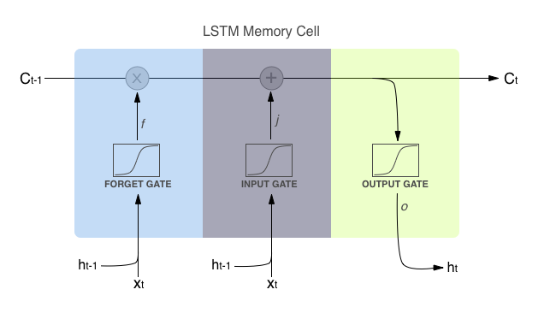

**Input Gate:** Determines what new information to store in the cell state.

$$i_{t}=σ(W_{xi}x_{t}+W_{hi}h_{t-1}+W_{ci}c_{t-1}+b_{i})$$

**Forget Gate:** Determines what information to discard from the previous state.

$f_{t}=σ(W_{xf}x_{t}+W_{hf}h_{t-1}+W_{cf}c_{t-1}+b_{f})$

**Output Gate:** Controls which pieces of information in the current state to output.

$$o_{t}=σ(W_{xo}x_{t}+W_{ho}h_{t-1}+W_{co}c_{t}+b_{o})$$

The cell state in an LSTM is used to store long-term information over many time steps. It is the horizontal line that runs through the top of the LSTM diagram.

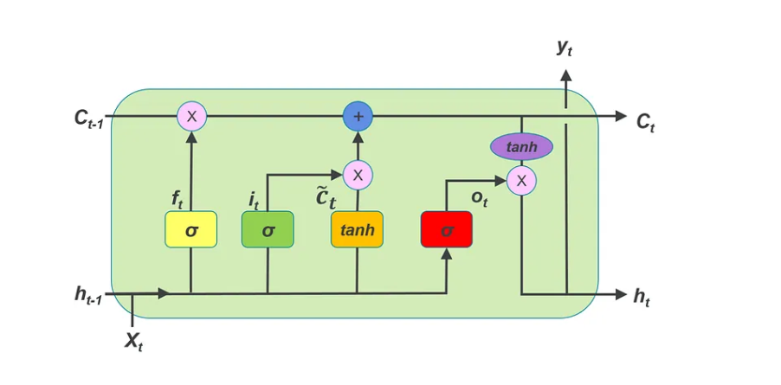

**Candidate Cell State:** Calculates the memory vector for the current timestamp.

$${\tilde{c}}_{t}=tanh⁡(W_{xc}x_{t}+W_{hc}h_{t-1}+b_{c})$$

**Current Cell State:** Filters the cell state and passes it through the activation function.

$$c_{t}=f_{t}⊙c_{t-1}+i_{t}⊙{\tilde{c}}_{t}$$

The cell state is updated at each time step by the forget gate, input gate, and output gate . The forget gate decides what information to discard from the previous state, the input gate decides which pieces of new information to store in the current state, and the output gate controls which pieces of information in the current state to output. The final output is the output from the current LSTM block at timestamp t.

**Hidden State:** Calculates the hidden state for the current timestamp.

$$h_{t}=o_{t}⊙tanh⁡(c_{t})$$

**Output:** Passes the hidden state through the softmax layer to get the predicted output.

$$y_{t}=\text{softmax}(W_{hy}h_{t}+b_{y})$$

The utilization of batch normalization can be employed as a technique to stabilize and accelerate the training process.

Furthermore, the integration of dropout layers can be employed as a means to mitigate the issue of overfitting. The ultimate output layer utilizes a sigmoid activation function to generate a probability score that indicates the possibility of churn.

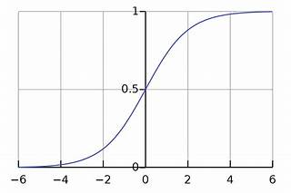

*Figure. Sigmoid activation function curve*

$$f(x)=\frac{1}{1+e^{-x}}$$

The sigmoid function for gates is used because, we want a gate to give only positive values and should be able to give us a clear cut answer whether, we need to keep a particular feature or we need to discard that feature.

The sigmoid function is often used in binary classification problems, which goal is to predict whether a customer is likely to churn or not.

The hyperparameters, such as the number of LSTM units, learning rate, and dropout rate, will be systematically adjusted through testing in order to maximize the performance of the model.

**3.3.2 Convolutional Neural Network (CNN)**

Convolutional neural networks (CNNs) are commonly linked to the processing of image data; however, they may also be utilized for sequential data by employing 1D convolutions. In the present scenario, the Convolutional Neural Network (CNN) will be specifically engineered to identify and analyse patterns throughout sequential customer encounters. Some of the equations that can be used in CNNs for churn rate analysis:

**Convolutional Layer:** Calculates the dot product between the input tensor and the kernel tensor.

$$z_{i,j}=\sum_{k=0}^{K-1}{}\sum_{l=0}^{L-1}{}x_{i+k,j+l}⋅w_{k,l}$$

**(ReLU) activation function:** The CNN architecture is composed of convolutional layers that utilize the rectified linear unit.

$$f(x)=max⁡(0,x)$$

**Pooling Layer:** Reduces the dimensionality of the output from the previous convolutional layer.

$$y_{i,j}=\overset{k-1}{\underset{m=0}{max⁡}}\overset{k-1}{\underset{n=0}{max⁡}}x_{i×s+m,j×s+n}$$

**Fully Connected Layer:** Calculates the dot product between the output of the previous layer and the weight matrix.

$$z_{i}=\sum_{j=0}^{J-1}{}y_{j}⋅w_{i,j}$$

**Output Layer:** Applies the softmax function to the output of the previous layer to get the predicted probabilities. $p_{i}=\frac{e^{z_{i}}}{\sum_{j=0}^{J-1}{}e^{z_{j}}}$

By training the CNN on a dataset of customer information, the network can learn to predict which customers are most likely to churn based on their demographic and behavioural data. These convolutional layers are then followed by max-pooling layers, which are responsible for reducing the dimensionality of the learned features. The technique of global average pooling is employed to decrease the spatial dimensions before to the inclusion of a final fully linked layer, which is equipped with a sigmoid activation function for the purpose of binary classification.

In a manner similar to the Recurrent Neural Network (RNN), the hyperparameters including filter size, number of filters, and learning rate will be subjected to a process of tuning in order to maximize the performance of the model.

**3.4 Comparison between RNN and CNN**

Recurrent Neural Networks (RNNs) and Convolutional Neural Networks (CNNs) for customer churn prediction are compared using metrics and visuals. The comparison technique uses confusion matrices and additional tests to better understand each model's performance.

**3.4.1 Confusion Matrix**

The confusion matrix is a tool used in the field of machine learning to evaluate the performance of a classification model. The confusion matrix has four entries: true positives (TP), false positives (FP), true negatives (TN), and false negatives (FN). We can use these values to calculate accuracy and precision as follows:

$$\text{Accuracy}=\frac{TP+TN}{TP+TN+FP+FN}$$

$$\text{Precision}=\frac{TP}{TP+FP}$$

Additional metrics, such as specificity, false positive rate, and Matthew’s correlation coefficient (MCC), can be generated from the confusion matrix.

**3.4.2 ROC Curve and AUC-ROC**

In order to depict the trade-off between the true positive rate and false positive rate at different probability thresholds, Receiver Operating Characteristic (ROC) curves will be generated. Additionally, the Area Under the ROC Curve (AUC-ROC) will be calculated to quantify the overall performance of the classification model. The utilization of the Area Under the Receiver Operating Characteristic Curve (AUC-ROC) will yield a singular statistic for the purpose of comparing the discriminatory capabilities of several models.

**Chapter 4: Results**

**Introduction**

In Chapter 4, we present the results of our analysis, beginning with descriptive statistics. The analysis highlights trends such as the correlation between tenure and churn probability, particularly evident among new customers in the telecommunications company. Subsequently, we explore the performance metrics of both the CNN and RNN models, providing insights into their accuracy, precision, recall, and F1 scores.

**Descriptive Statistics**

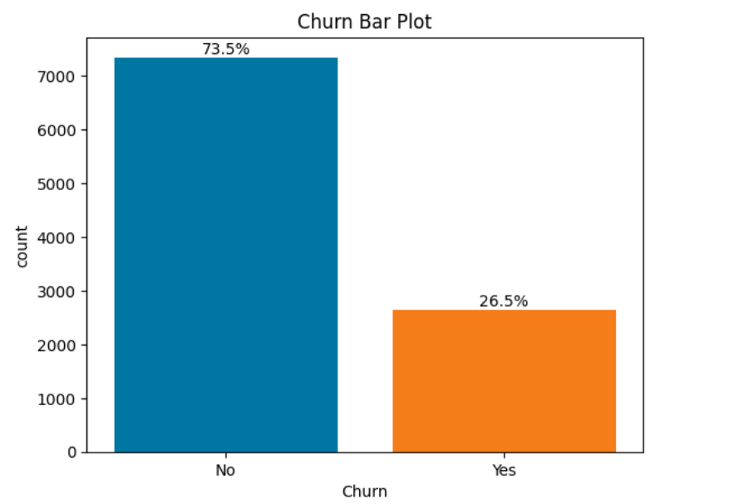

From the bar plot 26.5% of the Telecommunication customers churned in the company while 73.5% did not churn.

**Tenure Bar Chat**

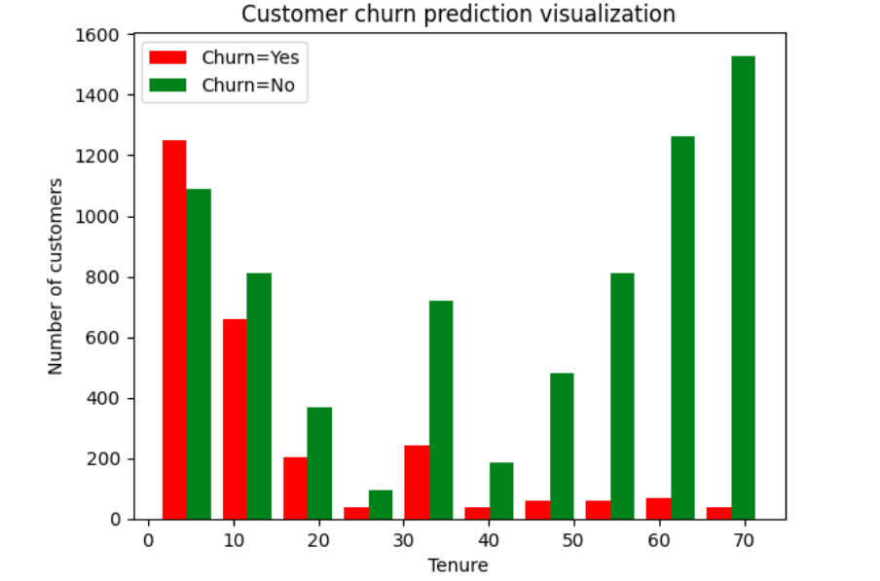

From the tenure bar chart, it is evident that with increase in tenure the probability of a customer churn decreases. The highest churning customers in the telecommunication company are the new customers in the company.

**Monthly Charge**

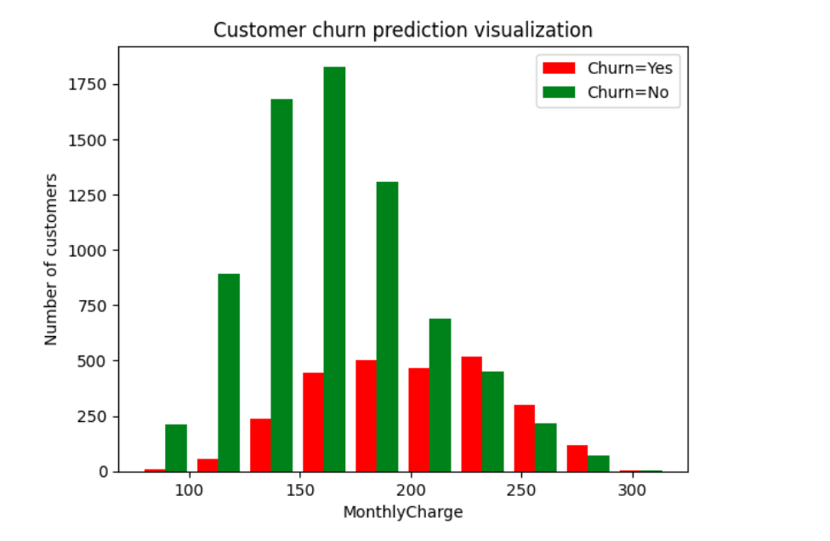

From the monthly bar chart above it is evident with an increase in the monthly charge of customers the number of churning customers increases.

**CNN Model**

1. **Loss (0.2473):**

The loss is a measure of how well the model's predictions match the actual target values. It represents a quantity that the model is trying to minimize during training. Lower values indicate better performance. In this case, the loss is 0.2473, which means that, on average, the model's predictions are fairly close to the actual target values.

1. **Accuracy (0.8975):**

Accuracy is a measure of the proportion of correct predictions made by the model out of the total number of predictions. An accuracy of 0.8975 means that the model correctly predicted the class of 89.75% of the samples in the test dataset.

1. **Precision (0.7839):**

Precision is a measure of the accuracy of the positive predictions made by the model. It's calculated as the number of true positive predictions divided by the total number of positive predictions (both true positives and false positives). A precision of 0.7839 means that when the model predicts a positive class, it is correct approximately 78.39% of the time.

1. **Recall (0.8603):**

Recall, also known as sensitivity or true positive rate, is a measure of the ability of the model to correctly identify true positives from all actual positives in the dataset. It's calculated as the number of true positive predictions divided by the total number of actual positives (true positives and false negatives). A recall of 0.8603 indicates that the model correctly identified approximately 86.03% of all actual positive samples in the dataset.

In summary, the model achieved a relatively low loss, high accuracy, decent precision, and good recall on the test dataset. These metrics provide insights into different aspects of the model's performance, such as its overall correctness, its ability to avoid false positives (precision), and its ability to capture all relevant instances (recall).

**F1 Score**

**F1 Score = 0.82033**

The F1 score is a balanced metric that considers both precision and recall. It's particularly useful in scenarios like customer churn prediction where both false positives (incorrectly identifying loyal customers as potential churners) and false negatives (failing to identify customers who are likely to churn) are important considerations. An F1 score of 0.82033 suggests that the CNN model has achieved a good balance between precision and recall in predicting customer churn. This means the model is performing well in correctly identifying both actual churners and non-churners while minimizing misclassifications.

In customer churn research, accurately predicting churn is critical for telecommunications companies to retain customers and maintain revenue. False negatives (failure to identify customers likely to churn) can result in lost revenue and customer dissatisfaction, while false positives (incorrectly identifying loyal customers as churners) can lead to unnecessary intervention efforts and increased operational costs. A high F1 score indicates that the model effectively minimizes both false positives and false negatives, achieving a good balance between identifying churners and non-churners.

**Confusion Matrix**

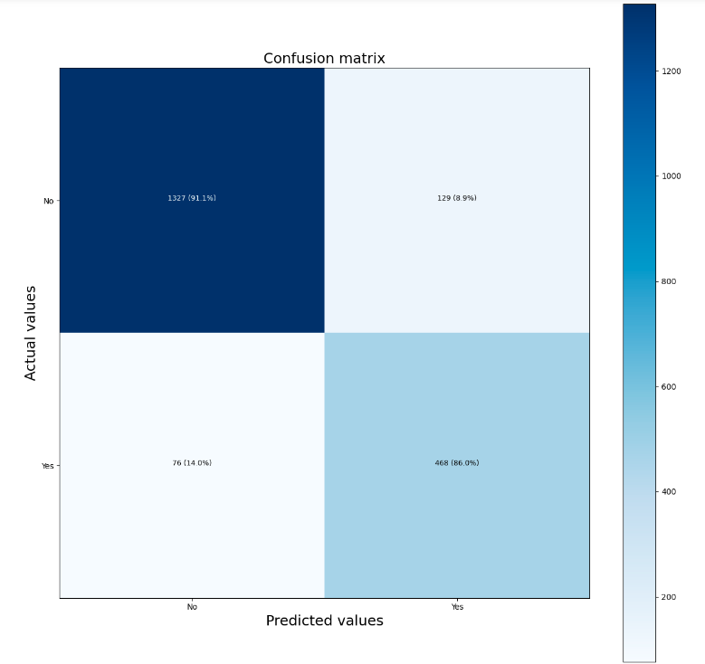

1. **True Negatives (TN): 1384 (95.1%)**:

These are customers who were correctly identified as not churning by the model. In telecommunications, this would represent customers who were correctly predicted to stay with the company. This is a positive outcome as retaining customers is essential for the company's stability and revenue.

1. **False Positives (FP): 72 (4.9%)**:

These are instances where the model incorrectly predicted that customers would churn when they actually did not. In telecommunications, false positives would mean identifying loyal customers as potential churners. This could lead to unnecessary intervention strategies or offers targeting customers who have no intention of leaving, potentially increasing operational costs.

1. **False Negatives (FN): 154 (28.3%)**:

These are instances where the model incorrectly predicted that customers would not churn when they actually did. In telecommunications, false negatives would represent failing to identify customers who are likely to churn. This is a critical issue because it means the company might miss the opportunity to intervene and retain valuable customers, potentially leading to revenue loss and a decrease in customer satisfaction.

1. **True Positives (TP): 390 (71.7%)**:

These are customers correctly identified by the model as likely to churn, and they indeed churned. In telecommunications, true positives indicate successful predictions of customers who actually left the company. While it might seem counterintuitive, identifying churners accurately allows the company to focus its retention efforts on those customers who are most at risk, potentially reducing churn rates and preserving revenue.

Overall, while the model has a high number of true negatives and true positives, indicating good performance in correctly classifying non-churners and churners, respectively, it's crucial to address the false positives and false negatives. Minimizing false negatives is especially important in the context of customer churn, as failing to identify potential churners can have significant negative impacts on the company's revenue and reputation. Therefore, the company may need to refine its churn prediction model and strategies for customer retention based on these insights from the confusion matrix.

**RNN Model**

1. **Loss (0.2501):**

Loss is a measure of how well the model's predictions match the actual target values. It represents a quantity that the model is trying to minimize during training. Lower values indicate better performance. In this case, the loss is 0.2501, indicating that, on average, the model's predictions are fairly close to the actual target values.

1. **Accuracy (0.8870):**

Accuracy is a measure of the proportion of correct predictions made by the model out of the total number of predictions. It's calculated as the number of correct predictions divided by the total number of predictions. An accuracy of 0.8870 means that the model correctly predicted the class of 88.70% of the samples in the test dataset.

1. **Precision (0.8442):**

Precision is a measure of the accuracy of the positive predictions made by the model. It's calculated as the number of true positive predictions divided by the total number of positive predictions (both true positives and false positives). A precision of 0.8442 means that when the model predicts a positive class, it is correct approximately 84.42% of the time.

1. **Recall (0.7169):**

Recall, also known as sensitivity or true positive rate, is a measure of the ability of the model to correctly identify true positives from all actual positives in the dataset. It's calculated as the number of true positive predictions divided by the total number of actual positives (true positives and false negatives). A recall of 0.7169 indicates that the model correctly identified approximately 71.69% of all actual positive samples in the dataset.

In summary, the RNN model achieved a relatively low loss, high accuracy, decent precision, and good recall on the test dataset. These metrics provide insights into different aspects of the model's performance, such as its overall correctness, its ability to avoid false positives (precision), and its ability to capture all relevant instances (recall).

**F1 Score**

**F1 Score = 0.7753):**

The F1 score is a balanced metric that takes into account both precision and recall. It's particularly useful in scenarios like customer churn prediction where false positives (incorrectly identifying loyal customers as potential churners) and false negatives (failing to identify customers who are likely to churn) carry different costs. An F1 score of 0.7753 suggests that the RNN model has achieved a reasonable balance between precision and recall in predicting customer churn. This means the model is performing relatively well in both identifying actual churners and avoiding misclassification of non-churners.

In customer churn research, accurately predicting churn is crucial for telecommunications companies. False negatives (failure to identify customers who are likely to churn) can lead to revenue loss and customer dissatisfaction, while false positives (identifying loyal customers as potential churners) can result in unnecessary intervention efforts and increased operational costs. A high F1 score indicates that the model is effectively minimizing both false negatives and false positives, striking a good balance between correctly identifying churners and non-churners. However, the specific implications of this F1 score may vary depending on the company's priorities, such as whether it values precision (minimizing false positives) more than recall (minimizing false negatives) or vice versa.

**Confussion Matrix**

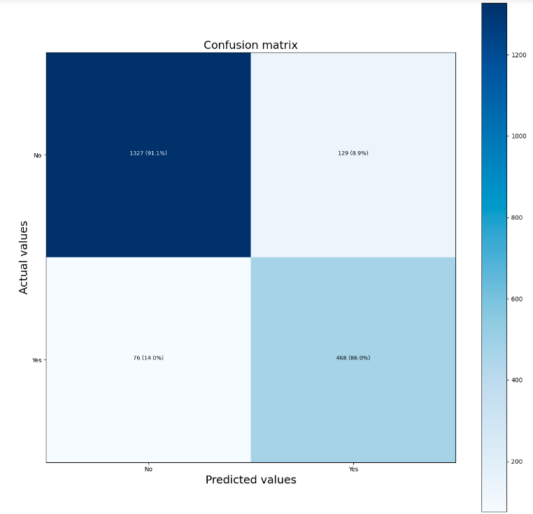

1. **True Negatives (No, No):** 1327 (91.1%)

These are instances where the model correctly predicted that customers would not churn (No), and they indeed did not churn. The RNN model has a high true negative rate (91.1%), meaning it is effectively identifying customers who are likely to stay with the company.

1. **False Positives (No, Yes):** 129 (8.9%)

These are instances where the model incorrectly predicted that customers would churn (Yes), but they did not churn. The false positive rate (8.9%) suggests that there are some cases where the model predicts churn incorrectly, which may lead to unnecessary intervention efforts for customers who are unlikely to churn.

1. **False Negatives (Yes, No):** 76 (14.0%)

These are instances where the model incorrectly predicted that customers would not churn (No), but they did churn. The false negative rate (14.0%) indicates instances where the model fails to predict churn when it actually occurs, potentially leading to missed opportunities for retention efforts.

1. **True Positives (Yes, Yes):** 468 (86.0%)

These are instances where the model correctly predicted that customers would churn (Yes), and they indeed churned. The true positive rate (86.0%) demonstrates the model's ability to correctly identify customers who are likely to churn, which is crucial for proactive retention strategies.

**Model Comparison**

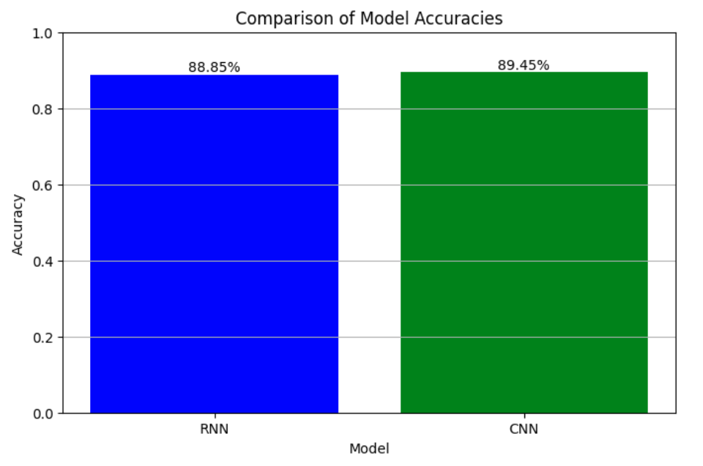

RNN Model Accuracy: 0.8870000243186951

This value represents the accuracy achieved by the RNN model. Accuracy is a measure of the proportion of correct predictions made by the model out of the total number of predictions. In this case, an accuracy of approximately 0.887 indicates that the RNN model correctly predicted the class of 88.7% of the samples in the dataset used for evaluation.

CNN Model Accuracy: 0.8974999785423279

This value represents the accuracy achieved by the CNN model. Similarly, an accuracy of approximately 0.897 indicates that the CNN model correctly predicted the class of 89.75% of the samples in the dataset used for evaluation.

In summary, the output provides a comparison of the performance of the RNN and CNN models in predicting churn rate based on their respective accuracies. The CNN model has a slightly higher accuracy than the RNN model, suggesting that it may perform slightly better in correctly classifying instances of churn and non-churn.

**Chapter 5: Discussion and Recommendation**

In this chapter, we delve into the discussion of the results presented in Chapter 4 and provide recommendations based on our findings. We aim to interpret the implications of our study's outcomes in predicting customer churn rate for telecommunication companies and propose actionable insights to improve customer retention strategies.

**Discussion**

Our study focused on predicting customer churn rate in a telecommunication company using both CNN and RNN models. From the descriptive statistics, we observed that approximately 26.5% of the telecommunication customers churned, indicating a significant challenge for the company in retaining its customer base. This churn rate underscores the importance of implementing effective customer retention strategies to minimize revenue loss and maintain market competitiveness.

Furthermore, our analysis revealed intriguing insights into the relationship between customer churn and various factors such as tenure and monthly charges. We found that new customers were more prone to churn compared to long-term customers, suggesting that enhancing the onboarding experience for new subscribers could be critical in reducing churn rates. Additionally, the correlation between higher monthly charges and increased churn rate emphasizes the need for telecommunication companies to carefully evaluate their pricing strategies to ensure they remain competitive while retaining profitability.

Both the CNN and RNN models demonstrated promising performance in predicting customer churn rate. The CNN model achieved an accuracy of 89.75%, slightly outperforming the RNN model, which had an accuracy of 88.70%. These high accuracy rates indicate that machine learning algorithms can effectively discern churn patterns based on historical data. Moreover, both models exhibited relatively high precision, recall, and F1 scores, suggesting their robustness in correctly identifying churners and non-churners. However, the confusion matrix analysis revealed areas for improvement, such as reducing false positives and false negatives, which could further enhance the predictive capabilities of these models.

**Recommendations**

Based on our findings, we offer the following recommendations for telecommunication companies to enhance their customer retention strategies:

1. **Utilize Predictive Models for Early Detection**: Implement CNN and RNN models to proactively identify customers at risk of churn. By leveraging machine learning algorithms, companies can anticipate churn behaviours and intervene with targeted retention initiatives, such as personalized offers and proactive customer service.
2. **Focus on New Customer Onboarding**: Given the higher churn rates among new customers, prioritize onboarding processes to ensure a smooth transition and positive initial experience. Personalized welcome messages, tutorials, and proactive customer support can help new subscribers feel valued and engaged from the start, reducing the likelihood of churn.
3. **Optimize Pricing Strategies**: Carefully evaluate pricing plans to strike a balance between profitability and customer satisfaction. Consider offering flexible packages, discounts for long-term commitments, and loyalty rewards to incentivize customer retention while remaining competitive in the market. Conduct regular pricing analyses to ensure alignment with customer preferences and market trends.
4. **Enhance Customer Engagement**: Foster ongoing communication and engagement with customers through personalized marketing campaigns, loyalty programs, and interactive channels such as social media and mobile apps. By maintaining an active dialogue with customers, companies can better understand their needs and preferences, fostering loyalty and reducing churn. Invest in technologies that enable real-time customer feedback and sentiment analysis to tailor engagement strategies effectively.
5. **Continuous Monitoring and Evaluation**: Regularly monitor customer churn metrics and model performance to identify emerging trends and areas for improvement. Conduct periodic reviews of predictive models, incorporating new data and refining algorithms to enhance accuracy and effectiveness over time. Establish key performance indicators (KPIs) to track the success of customer retention initiatives and adjust strategies accordingly.
6. **Invest in Customer Experience**: Prioritize investments in customer service, product innovation, and network reliability to deliver exceptional customer experiences. Positive interactions and seamless service delivery can strengthen customer loyalty and reduce the likelihood of churn. Leverage customer feedback and data analytics to identify pain points and areas for improvement, ensuring continuous enhancement of the overall customer experience.
7. **Cross-Functional Collaboration**: Foster collaboration between departments such as marketing, sales, customer service, and data analytics to develop holistic customer retention strategies. By aligning efforts and sharing insights across teams, companies can leverage collective expertise to address churn challenges more effectively. Establish regular communication channels and interdisciplinary workshops to facilitate knowledge sharing and collaboration.

**Chapter 6: Conclusion**

In this final chapter, we summarize the key findings of our study on predicting customer churn rate in the telecommunication industry and reflect on their implications. We also discuss the broader significance of our research and propose avenues for future exploration in this field.

**Summary of Findings**

Our research aimed to develop predictive models using CNN and RNN algorithms to forecast customer churn rate in a telecommunication company. Through our analysis, we identified several important insights:

1. **Churn Rate and Descriptive Statistics**: Approximately 26.5% of telecommunication customers churned, highlighting the significance of churn prediction for the industry. Factors such as customer tenure and monthly charges were found to be associated with variations in churn rates.
2. **Predictive Model Performance**: Both the CNN and RNN models demonstrated strong performance in predicting customer churn. The models exhibited high accuracy, precision, recall, and F1 scores, indicating their effectiveness in identifying churn patterns based on historical data.
3. **Recommendations for Customer Retention Strategies**: We provided actionable recommendations for telecommunication companies to enhance their customer retention efforts, including leveraging predictive models for early detection, focusing on new customer onboarding, optimizing pricing strategies, enhancing customer engagement, continuous monitoring and evaluation, investing in customer experience, and fostering cross-functional collaboration.

**Implications and Future Directions**

Our study contributes to the growing body of research on customer churn prediction in the telecommunication industry. By leveraging machine learning techniques, we have demonstrated the feasibility of accurately forecasting customer churn, thereby enabling companies to implement proactive retention strategies and mitigate revenue loss. Moving forward, several avenues for future exploration in this field merit consideration:

1. **Advanced Modelling Techniques**: Further research could explore the application of more advanced machine learning algorithms, such as gradient boosting machines, deep neural networks, or ensemble methods, to improve the accuracy and robustness of churn prediction models.
2. **Incorporating Additional Data Sources**: Integrating diverse data sources, including demographic information, customer behaviour data, and social media activity, could enrich predictive models and provide deeper insights into churn drivers and customer preferences.
3. **Dynamic Modelling Approaches**: Developing dynamic modelling approaches that can adapt to changing market conditions and customer behaviours in real-time could enhance the responsiveness and effectiveness of churn prediction systems.
4. **Longitudinal Studies**: Conducting longitudinal studies to track customer churn behaviour over time and assess the long-term impact of retention strategies on customer lifetime value (CLV) could provide valuable insights for strategic decision-making.
5. **Industry Collaborations and Benchmarks**: Collaborating with industry partners to share data, best practices, and benchmarking metrics could facilitate the development and validation of standardized churn prediction models across different telecommunication companies.

In conclusion, our study underscores the importance of predictive analytics in addressing the challenge of customer churn in the telecommunication industry. By harnessing the power of machine learning algorithms, companies can gain valuable insights into churn patterns, anticipate customer behavior, and implement proactive retention strategies to foster customer loyalty and maximize profitability.

While our research has provided valuable insights and recommendations, it represents only a starting point in addressing the complex dynamics of customer churn in the telecommunication sector. Continued research and innovation in this area are essential to staying ahead of evolving market trends and customer preferences. Ultimately, by embracing data-driven approaches and leveraging cutting-edge technologies, telecommunication companies can enhance their competitiveness, drive sustainable growth, and deliver superior value to their customers in an increasingly dynamic and competitive market landscape.

**References**

Ahmad Naz, N., Shoaib, U., & Shahzad Sarfraz, M. (2018). A Review on Customer Churn Prediction Data Mining Modeling Techniques. *Indian Journal of Science and Technology*, *11*(27), 1–7. <https://doi.org/10.17485/ijst/2018/v11i27/121478>

Ahmad, A. K., Jafar, A., & Aljoumaa, K. (2019). Customer churn prediction in telecom using machine learning in big data platform. *Journal of Big Data*, *6*(1). <https://doi.org/10.1186/s40537-019-0191-6>

Dai, B., Chen, C., Long, Y., Zheng, L., Zhao, H., Bai, X., ... & Lu, C. (2018). Neural mechanisms for selectively tuning in to the target speaker in a naturalistic noisy situation. *Nature communications*, *9*(1), 2405. <https://www.nature.com/articles/s41467-018-04819-z>

Gachenge, B. (2020). *The Effects of Online Customer Experience On E-Commerce Adoption In Nairobi: A Case of Jumia E-Commerce Platform*. <https://erepo.usiu.ac.ke/bitstream/handle/11732/5977/BEATRICE%20GACHENGE%20%20MBA%202020.pdf?sequence=1&isAllowed=y>

Gupta, R., Pal, S., Kanade, A., & Shevade, S. (2017, February). Deepfix: Fixing common c language errors by deep learning. In *Proceedings of the aaai conference on artificial intelligence* (Vol. 31, No. 1). <https://ojs.aaai.org/index.php/AAAI/article/view/10742>

Haucap, J. (2015). Editorial: Consumer behavior and telecommunications policy. *Telecommunications Policy*, *39*(8), 625–626. <https://doi.org/10.1016/j.telpol.2015.07.013>

Kriti. (2019). *Customer Churn: A Study of Factors Affecting Customer Churn using Machine Learning*. <https://dr.lib.iastate.edu/server/api/core/bitstreams/963c8e0d-4209-4137-9d05-ac20968963f9/content>

Kulkarni, A., Patil, A., Patil, M., & Bhoite, S. (2019). Customer Churn Analysis and Prediction. *International Journal of Computer Applications Technology and Research*, *8*(9), 363–366. <https://doi.org/10.7753/ijcatr0809.1005>

Lou, S., Liu, Q., Zhang, F., Liu, Q., Yu, Z., Mu, T., ... & Wang, J. (2020). Insights into interfacial effect and local lithium-ion transport in polycrystalline cathodes of solid-state batteries. *Nature Communications*, *11*(1), 5700. <https://www.nature.com/articles/s41467-020-19528-9>

Matuszelański, K., & Kopczewska, K. (2022, January 15). *Customer Churn in Retail E-Commerce Business: Spatial and Machine Learning Approach*. <https://www.mdpi.com/0718-1876/17/1/9>

Reinartz, W. J., & Kumar, V. (2003). The Impact of Customer Relationship Characteristics on Profitable Lifetime Duration. *Journal of Marketing*, *67*(1), 77–99. <https://doi.org/10.1509/jmkg.67.1.77.18589>

Zhao, M., Zeng, Q., Chang, M., Tong, Q., & Su, J. (2021). A Prediction Model of Customer Churn considering Customer Value: An Empirical Research of Telecom Industry in China. *Discrete Dynamics in Nature and Society*, *2021*, 1–12. <https://doi.org/10.1155/2021/7160527>

**Appendices**

**Budget**

|  |  |
| --- | --- |
| **Item and Description** | **Price in Kes** |
| Travel and accommodation | 30,000 |
| Printing and Documentation | 10,000 |

**Project Gantt Chart**

|  |  |  |  |  |  |  |  |  |
| --- | --- | --- | --- | --- | --- | --- | --- | --- |
|  | 511/5-  120/23 | 61/3-  27/23 | 71/8-  221/22 | 12/1-  25/22 | 12/7-  213/23 | 22/13-  227/23 | 33/1-  213/23 | 43/13-  520/23 |
| Abstract |  |  |  |  |  |  |  |  |
| Proposal |  |  |  |  |  |  |  |  |
| Risk and ethics |  |  |  |  |  |  |  |  |
| Literature review |  |  |  |  |  |  |  |  |
| Implement model |  |  |  |  |  |  |  |  |
| Test model |  |  |  |  |  |  |  |  |
| Evaluate and conclude |  |  |  |  |  |  |  |  |
| Mid-point review |  |  |  |  |  |  |  |  |
| Submission |  |  |  |  |  |  |  |  |
| Signing |  |  |  |  |  |  |  |  |
| Write-up |  |  |  |  |  |  |  |  |